Kaila Silva

Dr. S. Brigette Whaley

EDPD 4330

Jan 22, 2024

Ice Breaker

**Original Version: 1. "Two Truths and a Lie"**

Objective: This game encourages students to share interesting facts about themselves and fosters a sense of camaraderie.

Materials Needed: None.

Instructions: Each student takes a turn to state two true facts and one false fact about themselves. The order of these statements should be random.

The rest of the class tries to guess which statement is the lie.

After the class votes on which statement, they believe is a lie, the student reveals the correct answer.

**Likes:** I like that this “Ice Breaker” because it starts off straight with saying two true facts about themselves which the classmates will learn. This also makes the students think a little and warm up their brains. I also like the fact that this gets the students to interact all together and leaves nobody out because everyone gets a chance. This can find similarities within students and build connections and a good learning environment.

**Don’t like and Improvement:** I don’t like that they must state a false fact, I would improve this ice breaker by making my students state two true facts and instead of a false fact a surprise to one of their facts.

**Update Version High School Spanish Class:** "Two Truths and a one Surprise" “Dos verdades y una sorpresa”

Objective: This game gives students basic fun knowledge about their peers and introduces them to the new language they will be using. Students will guess out of two facts witch fact has a surprise to it and with peers they will deliberate on and discuss the answers.

Materials Needed: Piece of paper, English to Spanish translator on computer.

Instructions: Each student writes down two true facts and one of the two facts with a surprise translated from English to Spanish. The order of these statements should be random and tricky. As the students state the two facts, they should all say the English version first, then try there best to say the Spanish version.

The students will then guess which fact has the surprise and that can be answered in English, but student then must respond their surprise in English then Spanish. Speaking Spanish will be someone everyone will be doing in the classroom, so it should not overwhelming and perfect. The class will start getting a warmup on the language, with this activity.

**1: Ice Breaker Name: Bingo Card Spanish High School Class:**

**My Bingo Card:**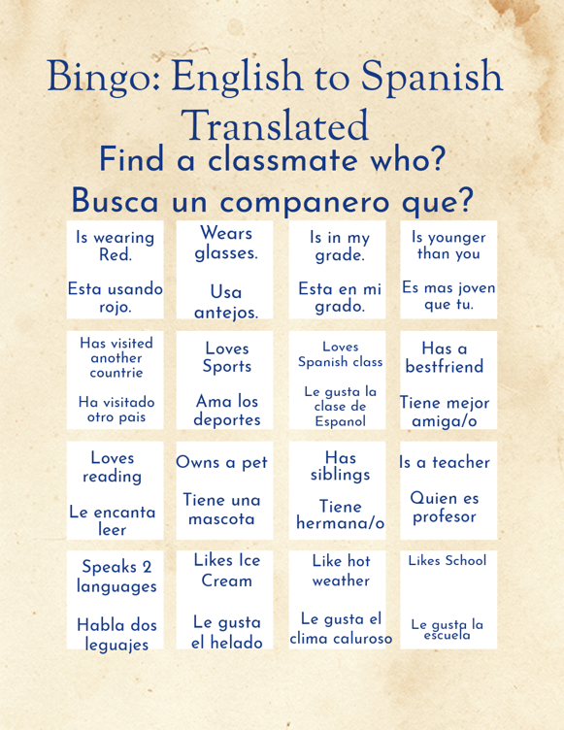

**Objective:** This bingo card will get students to stand up and do a hands-on activity. This will be a go around and get to know your classmates. The sentence will also be translated from English to Spanish to practice vocabulary.

**Materials Needed:** A pencil, pen, and bingo card.

**Instructions:** Students will pick up a bingo card and will go around and conversate with classmates to see who matches what’s inside the box and will get initials, so teacher knows theres no cheating. The first person to fill up the whole bingo card will, win.

**Cites Inspo Idea:**

<https://spanishwithstephanie.com/5-icebreakers-for-the-first-week-of-spanish/>

2: **Ice breaker name: my name is, and I bring to the table?**

**Objective:** This ice breaker gives the students the knowledge that they always have something to bring to the table in any setting. There is never such a thing as someone feeling left aside, we all have something to offer.

**Materials:** None.

**Instructions:** Students will stand in a circle, and someone will volunteer to start and say Example: My name is Kaila, and I am bringing Kisses to the table.

The next student will have to say their name and the name of the person before them and say also what they brough to the table.

Example: My names Lizbeth and I bring lollipops; Kaila is bringing kisses.

The game will continue till we get to the end of the circle.