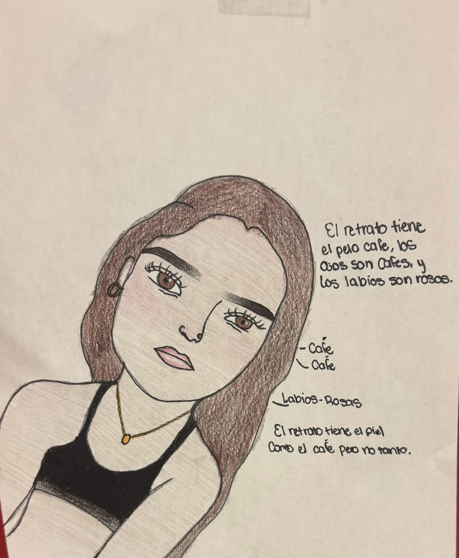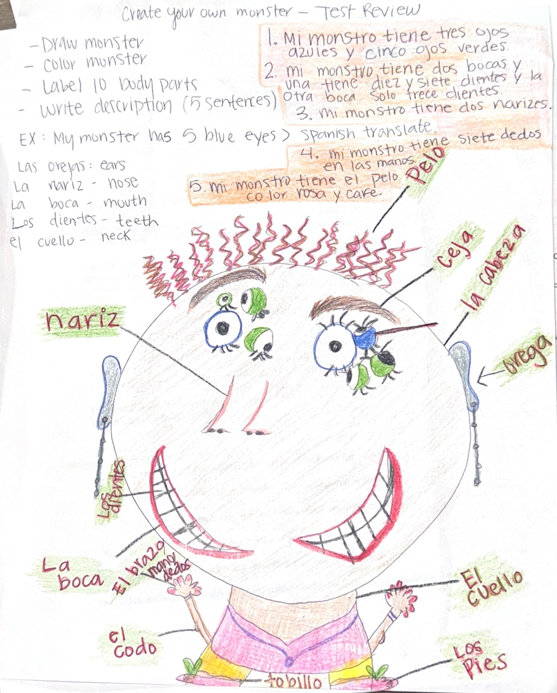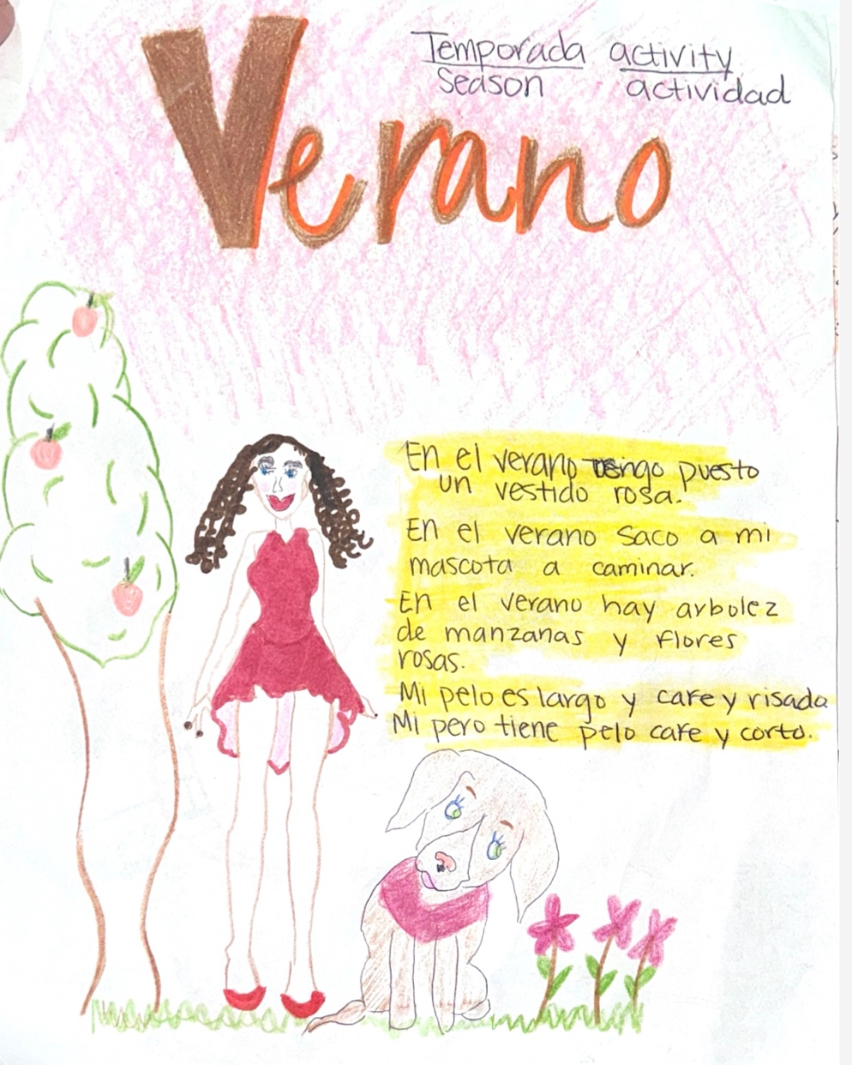

Students will create a self-portrait to demonstrate their understanding of the end-of-chapter with a fun activity. Throughout the 6 weeks, we learned between drawings, self-portraits, photographs, and structures from English to Spanish. We also practiced describing people in various forms of visual art, including photographs, drawings, and self-portraits, by translating emotions such as serious or happiness, hair length and color, skin tone, and eye color. This encourages self-expression through drawing, and students will label their work in Spanish using the vocabulary they have learned.

Auto Retrato/ Self- portrait drawing Activity.
Create your own Monter Activity

In the "Create Your Own Monster" activity, students will explore and apply their knowledge of body parts such as eyes, mouth, teeth, elbows and ears. Using their vocabulary and art skills, they will design a frightening incorporating at least 10 different body parts. The monster must be colored and labeled with the 10 body parts. Additionally, students will write a descriptive about their monster consisting of a minimum of 5 sentences. This activity encourages and allows students to practice their Spanish vocabulary related to body parts. Drawing allows students to create visual associations with the words, making them more memorable and easier to recall in the long term.

Season Activity/Actividad de Temporadas: Students will explore Spanish vocabulary related to clothing items and participate in a three-day activity where they will themselves in creative seasonal outfits for summer, winter, fall, and spring. activity will be graded based on creativity, background appropriateness of the season outfit, and students will also write 5 sentences for each season explaining their, the colors of the clothing pieces, and why they are suitable for that season. Students will utilize their vocabulary to describe their hair as well.

Season Activity/ Activididad de Temporada

