Bell Work: Fill in the blank

1.El tipo de arte es un/una _______ de México. (Retrato)

2.El retrato es de una/ un ________.

3.En el retrato ella es _______ (Joven o Vieja).

4.Ella esta _____? (Seria o feliz)

5. Los ojos son ______(Chicos o grandes) y de color _____? Marrones

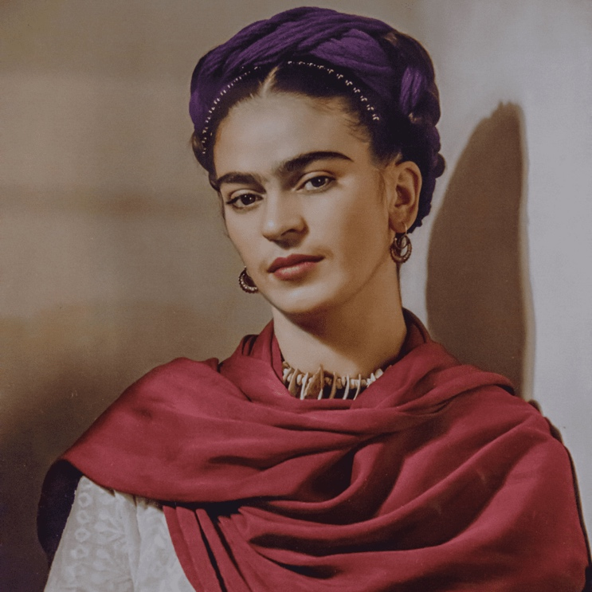

Frida Kalo

Víctimas o voluntarios: Come up to the board…

Next up well be reviwing with flash cards, everyone Will get an A, B, C, & D card.

Review:

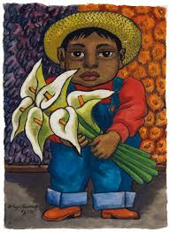

Raise up A, B, C or D: depending on what you the option is…

1.

A. Ella es Vieja

B. El es Joven

C. El es feliz

D. Ella esta Triste

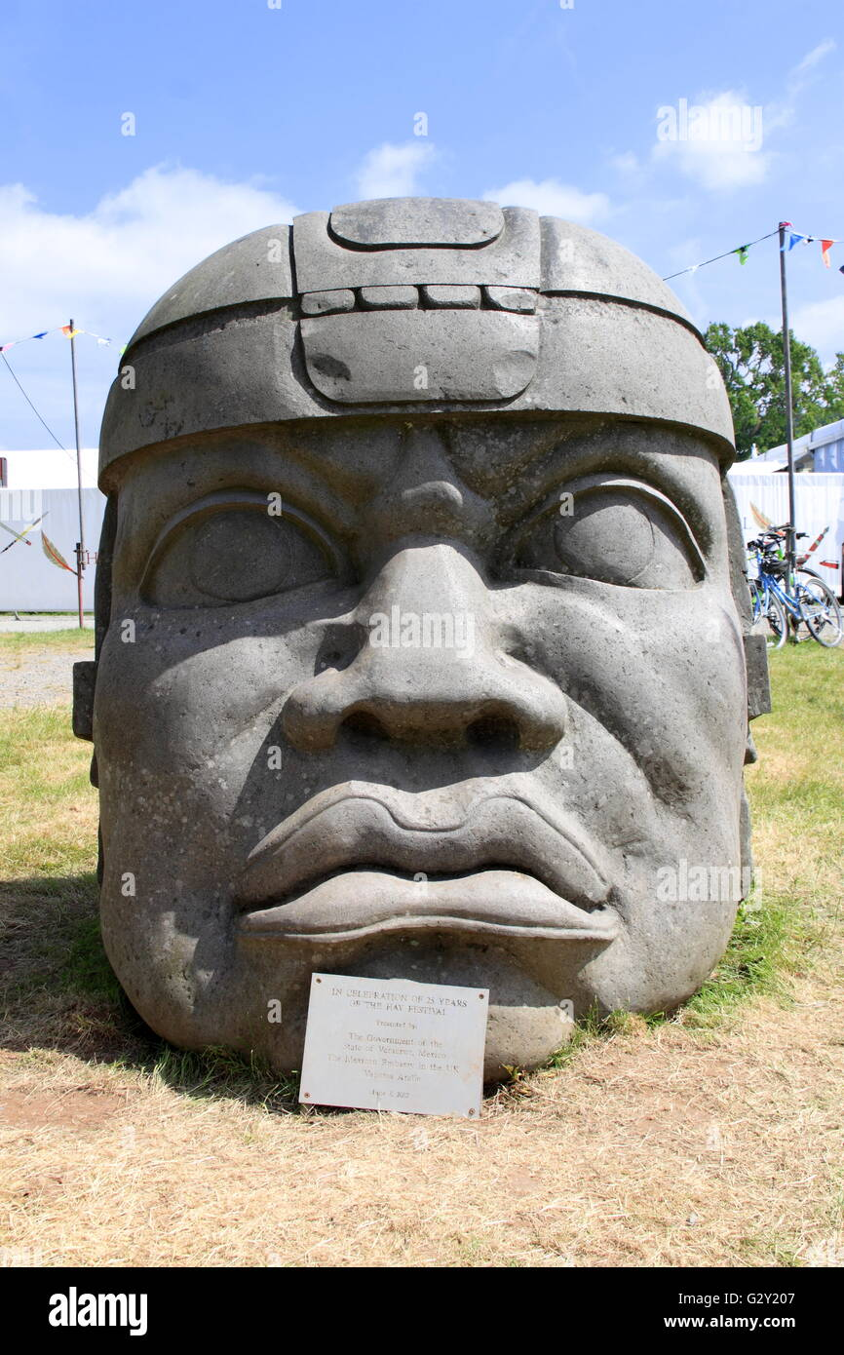

2.

A. Este arte es un tipo de dibujo.

B. Es una escultura.

C. La escultura esta feliz.

D. La escultura es bonita.

3.

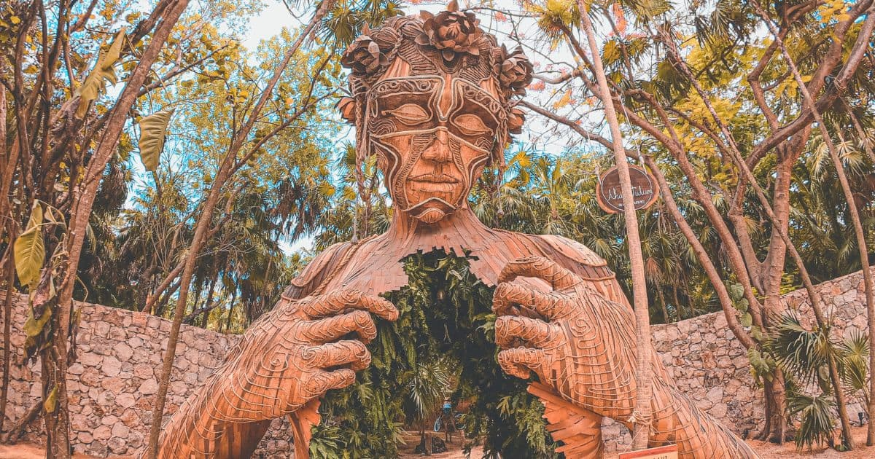

1. Es un Dibujo de la naturalesa.
2. Es una pintura de un hombre.
3. Es una fotografia feliz.
4. Es una escultura de la naturalesa.

4.

1. El esta serio y aburrido.
2. El es viejo y guapo.
3. El tiene el pelo largo.
4. El es calvo.

Next up is our activity which will either label picture number 1 or 2, It will not be the same as your partners.

Activity: Describe and label your drawing

-Describe your chosen artwork out of 2 art works.

-Do not have the same as your partner, the person sitting next to you.

Warp up:

Turn and talk with partners- about what yall wrote.

A few volunteers to tell me something they learned, enjoyed, or said about the drawing they choose.

Thank yall, continue working on your self-portrait, good job everyone.

In 4 to 5 sentences describe Fridas or Vicente Fernandez. The description can include their age, eye color or size, their hair lenth or color, physical appreriance, or emotions. This must be all written in spanish, use bell work, or review to help you out to start your sentences. Raise your hand if your need my assistance.

Frida Kalo es de Coyoacán, México. Ella es famosa por sus retratos. ____________________________________________________________________________________________________________________________________________________________________________________________________________________________________________________________________________________________________________________________________________________________________________________________________________________________________

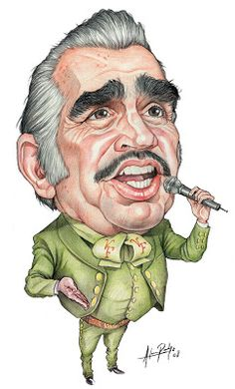

Vicente Fernandez es de Guadalajara Jalisco. El es un Famoso cantante Mexicano. ____________________________________________________________________________________________________________________________________________________________________________________________________________________________________________________________________________________________________________________________________________________________________________________________________________________________________

Vocabulary List:

El pelo →hair

1. El pelo largo → long hair
2. El pelo corto →short hair
3. El pelo rizado →curly hair
4. El pelo ondulado →wavy hair
5. El pelo liso →straight hair
6. El pelo negro →black hair
7. El pelo castaño →brown hair/ brunette
8. El pelo rubio →blond hair
9. El pelo rojo →red hair
10. El pelo pelirrojo →red hair
11. El pelo canoso →gray hair
12. El pelo blanco →white hair
13. Calvo →bald

Ojos→ eyes

1. Los ojos marrones →brown eyes
2. Los ojos negros → black eyes
3. Los ojos azules →blue eyes
4. Los ojos avellanos→ hazel eyes
5. Los ojos miel → hazel eyes
6. Los ojos verdes → green eyes
7. Los ojos grandes → big eyes
8. Los ojos pequeños →small eyes
9. Persona o Animal

Physical Looks- Aparencia fisica

1. Bonit@ →pretty
2. Hermos@ →beautiful
3. lind@ →cute
4. Precios@ → precious
5. fe@ → ugly

Emociones- Emotions

1. Triste →sad
2. aburrid@ → boring
3. Seri@ → Serious
4. Feliz- Happy

Tipo de arte → Type of art

1. Retrato → portrait
2. Fotografia→ photography

1. Dibujo→ drawing
2. Pintura → paint
3. Escultura →sculptured

Edad → Age

1. Joven → youth
2. Viej@→ Old